Experiment-1
DFA for Strings That Start with a and End with a
Aim:
To write a C program to simulate a Deterministic Finite Automaton (DFA) that accepts strings starting and ending with a.
Algorithm:
- Start the program.
- Read the input string containing a and b.
- Find the length of the string.
- Check whether the first character is a.
- Check whether the last character is a.
- If both conditions are true, print String Accepted.
- Otherwise, print String Rejected.
- Stop the program.
Implementation
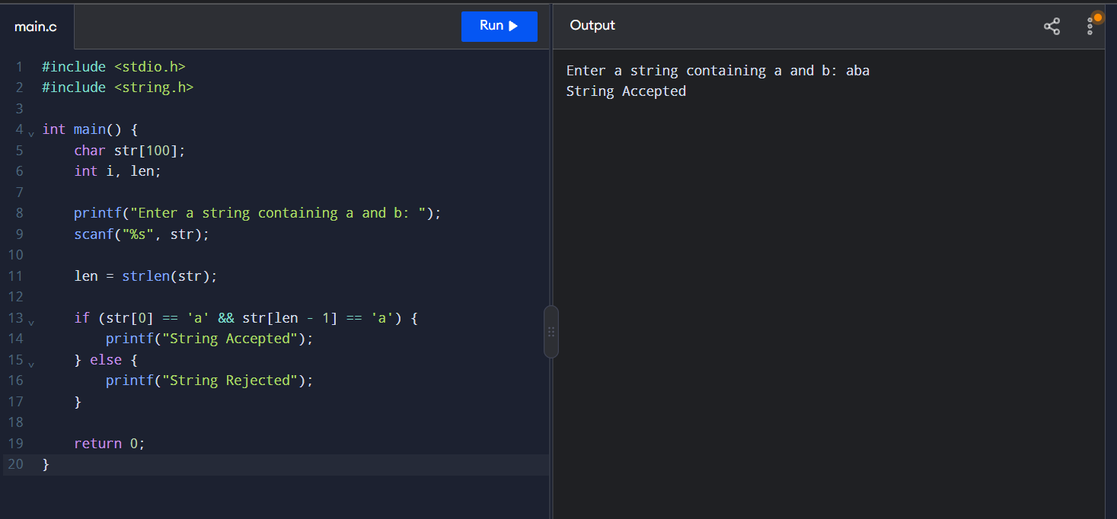
Result:
Thus, the C program to simulate a DFA that accepts strings starting and ending with a was executed successfully.

Experiment-2
DFA for Strings That Start with 0 and End with 1
Aim:
To write a C program to simulate a Deterministic Finite Automaton (DFA) that accepts binary strings starting with 0 and ending with 1.
Algorithm:
- Start the program.
- Read the input binary string containing 0 and 1.
- Find the length of the string.
- Check whether the first character is 0.
- Check whether the last character is 1.
- If both conditions are true, print String Accepted.
- Otherwise, print String Rejected.
- Stop the program.
Implementation:
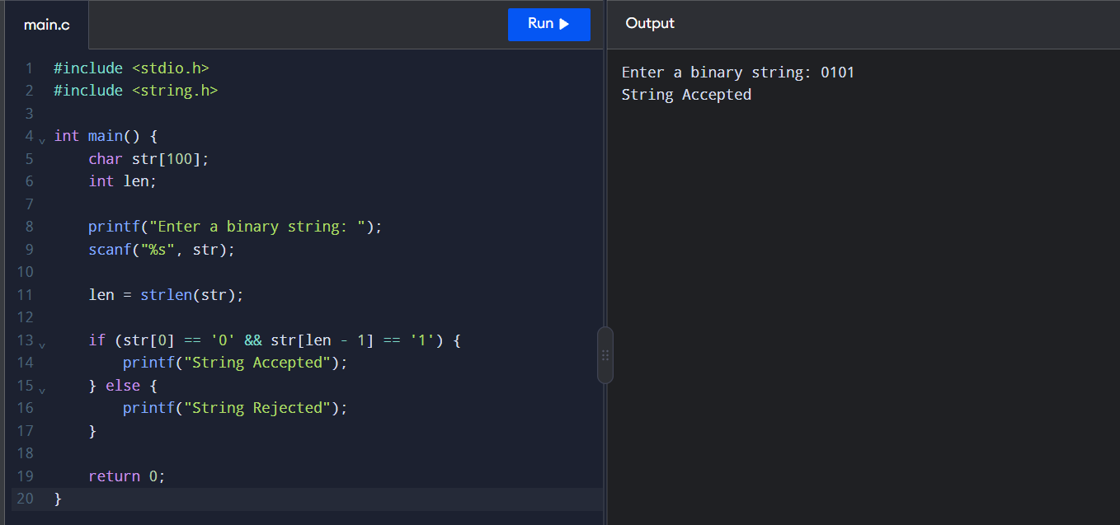
Result:
Thus, the C program to simulate a DFA that accepts binary strings starting with 0 and ending with 1 was executed successfully.

